 

Cairo University Computer Engineering

Faculty of Engineering First Year

Robotics

Under Supervision of :

Dr. Nessreen M. El Abiad

Prepared By:

2020

1. Esraa Gamal Saad Ahmed
2. Esraa Amr Mohammed Amr
3. Bassant Abd El Aziem Mohammed
4. Rawaa Ahmed Said Hanafy
5. Menna Allah Ahmed Ali Mohammed

2020

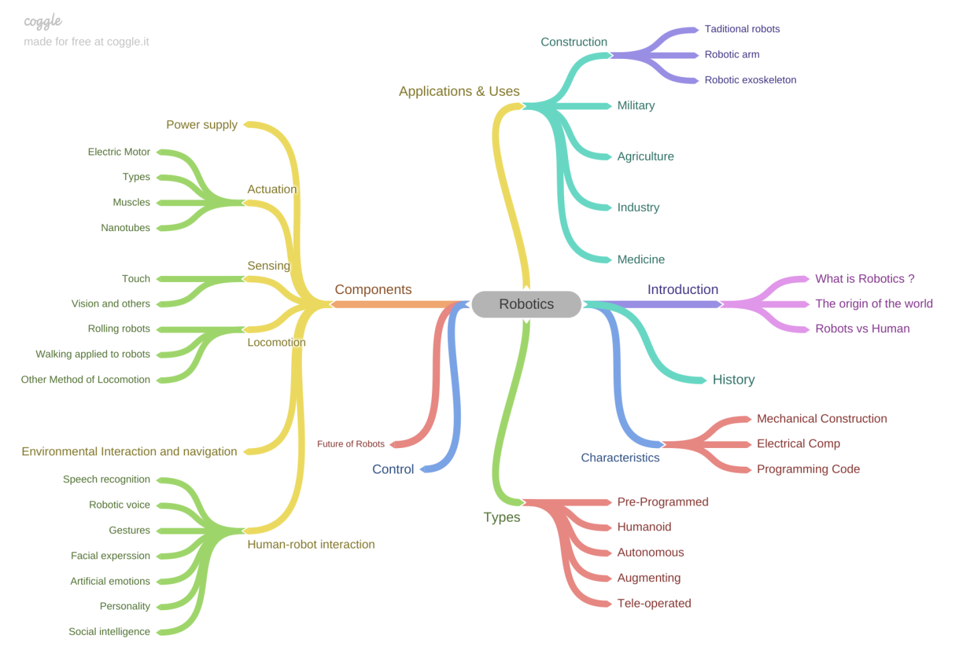Robotics Outline

**Thesis**: Robotics is a technology that combines science and engineering (mechanical ,electronic , computer) and others.

**1. Introduction.**  
 1.1. What is robotics?  
 1.2. The origin of the word " robotics "(Etymology).  
 1.3. In which way robots are better than humans?  
**2. History of robotics.  
3. Robots characteristics.** 3.1. Mechanical construction.  
 3.2. Electrical components.  
 3.3. Programming code.  
**4. Types of robots.**  
 4.1. Pre-programmed robots.  
 4.2. Humanoid robots.  
 4.3. Autonomous robots.  
 4.4. Tele-operated robots.  
 4.5. Augmenting robots.  
 **5. Applications and Uses of robots.**  
 5.1. Military.  
 5.2. Industry.  
 5.3. Construction.  
 5.3.1. Traditional robots.  
 5.3.2. Robotic arm.  
 5.3.3. Robotic exoskeleton.  
 5.4. Medicine.  
 5.5. Agriculture.  
**6. Components.** 6.1. Power supply.  
 6.2. Actuation.  
 6.2.1. Electric motor.  
 6.2.2. Types of actuators .  
 6.2.3. Muscles.  
 6.2.4. Nanotubes.  
 6.3 Sensing.  
 6.3.1. Touch.  
 6.3.2 Vision and others.  
 6.4. Manipulation.  
 6.5. Locomotion.  
 6.5.1. Rolling robots.  
 6.5.2. Walking applied to robots .  
 6.5.3. Other methods of locomotion.  
 6.6. Environmental interaction and navigation.  
 6.7. Human-robot interaction.  
 6.7.1. Speech recognition.  
 6.7.2. Robotic voice.  
 6.7.3. Gestures.  
 6.7.4. Facial expression .  
 6.7.5. Artificial emotions .  
 6.7.6. Personality.  
 6.7.7. Social Intelligence.  
**7. Control.  
8. The future of robots and robotics.   
9. Conclusion.**